**Test Case 3**: “**Most Visited(Individual)**” Section, which tracks the **5 Most Visited Products of EACH INDIVIDUAL USER** for each of the Member Companies(we assume the user is already logged in)

**Step1**: Click on “**Gotech Smart Solutions**” on the Products Page of the Marketplace, which will take you to the Products Page of Gotech Smart Solutions

**Step 2**: Visit the **Most Visited(Individual)** Section at the top and notice the Top 5 with their numbers.

**Step 3**: Now, click on any of the 10 products mentioned there(preferably more than 2)

**Step 4**: Come back to the “Most Visited(Individual)Section on the Products Page and notice the Top 5 Products along with their numbers changed along with their respective Google charts(PLEASE NOTE: THIS IS SPECIFIC TO EACH USER: i.e. EACH USER GETS TO SEE HIS/HER INDIVIDUAL MOST VISITED PRODUCTS)

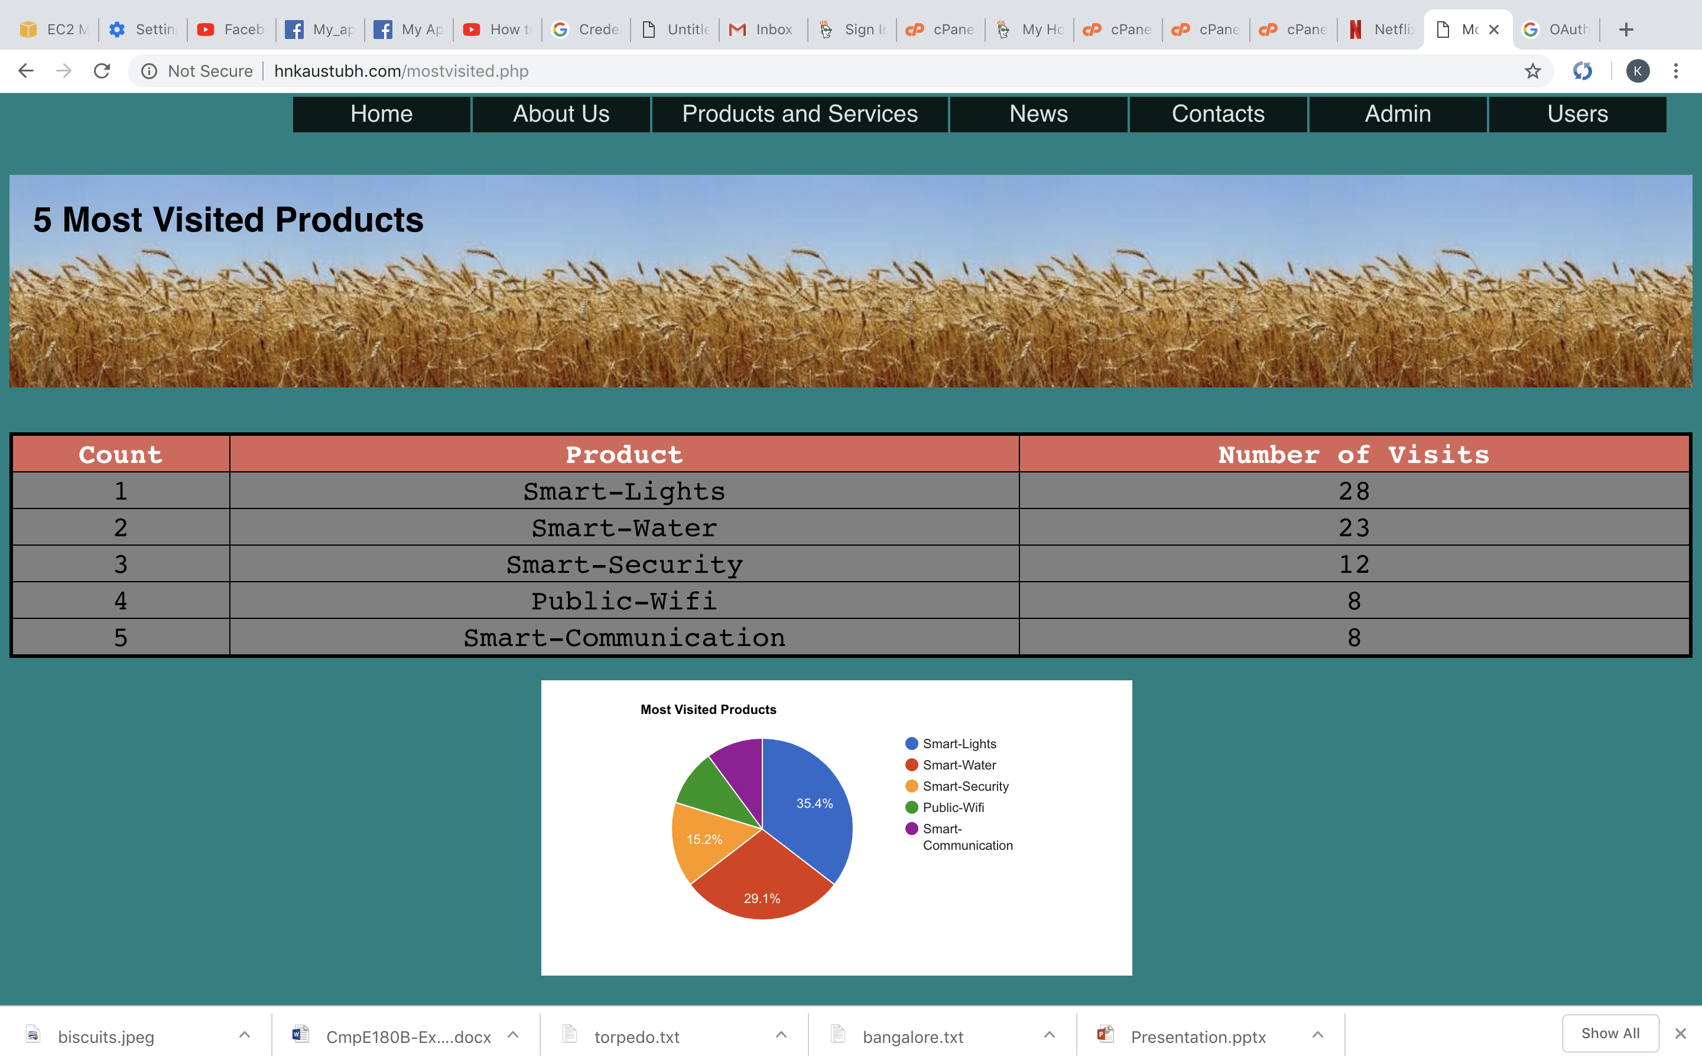

**Test Case 4: “Most Visited(Overall)”** Section, which tracks the **5 Most Visited Products of ALL USERS**for each of the Member Companies, as well as for the Entire Marketplace(we assume the user is already logged in)

**Step 1**: Click on “**Gotech Smart Solutions**” on the Products Page of the Marketplace, which will take you to the Products Page of Gotech Smart Solutions

**Step 2**: Visit the **Most Visited(Overall)** Section at the top and notice the Top 5 with their numbers.

**Step 3**: Now, click on any of the 10 products mentioned there(preferably more than 2)

**Step 4**: Come back to the “**Most Visited(Overall)** Section on the Products Page and notice the Top 5 Products along with their numbers changed along with their respective Google Charts (PLEASE NOTE: THIS GIVES THE MOST VISITED FOR ALL THE USERS AND NOT JUST ONE)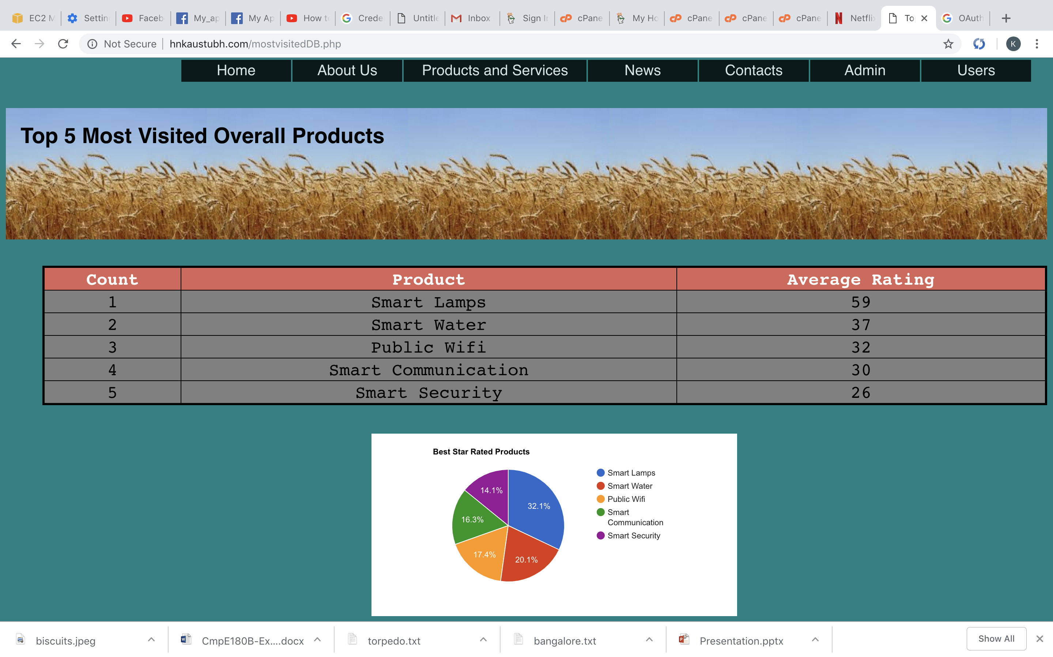

**Step 5:** Come back to the **Main Home Page** of the Marketplace(http://[madhukalluraya.com/final.php](http://madhukalluraya.com/final.php)**),** click on **Products,** scroll downand then click on **“Most Visited Products of our Marketplace”** section to view **“Top 5 Most Visited Products of the Entire Marketplace"**

